Sellers Page
I strive to provide unparalleled customer service so that my clients, both buyers and sellers, are thrilled with the outcome and comfortable with the entire process. I make it my mission to be resourceful, responsive, and attentive to each client, supporting them with the most progressive and efficient technology. Giving them the most options and making sure the option is best for your situation on selling your house. Every seller and current market conditions do change the strategies and options in Real-Estate and I will work with you to make sure the option you choose is the best one for your situation. Sometimes your situation might need a AS/IS sale, or a short term selling period like a relocation, every sale is different and I will explore all of them with you so you have the best options for Your Situation. Below I will have bullet points on what typically happens during the process, there are many steps inside each point but this gives you an idea on the process. I have many years of experience that will help and guild you though this Real-Estate Maze.
Michael Bohlman is
“Turning Dream Into Reality”

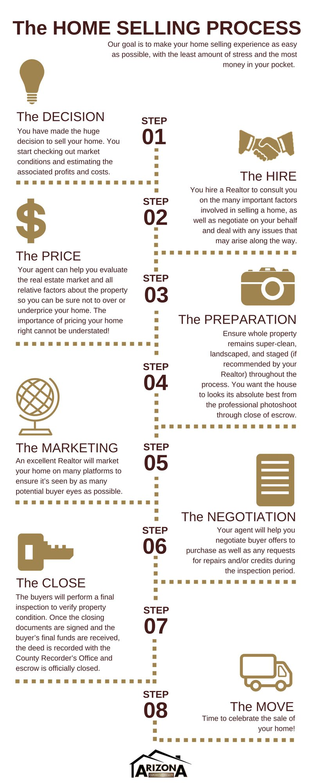

If you feel that you do not want the hassle of putting your home on the market and have to deal with the every day details of selling your home like for example, showings or miss appointments from other agents, keeping your property clean and organized all the time. You know there is another way of selling your home. I will work with you to give you other options like selling your home AS/IS, No Commissions, No showings, No Repairs, No Hassles during the selling process, or the worry of what happens if it does not sell. We can work with you on selling your home AS/IS, Cash sale within 24HRS, that right , No Repairs Needed, No Commissions , AS/IS Sale, You pick the closing date that works for you, you need to rent back the property after I purchase it ,No Problem, we can make it work so it is a Win Win Situation for both sides. If you have questions on this option please don’t hesitate to ask because not every seller or situation is the same in Real-Estate. I always make every transaction as personable as possible and will work with you to make sure what ever option you choose works best for your situation.

Michael Bohlman is
“Turing Dreams Into reality”

